**The Effects of Green Digital Transformation Leadership and** **Normative Pressures on Sustainability Development**

Meimei Han1, Lei Li 2 [1]

1(First author address) Ph.D. Student, Dept. of Global Business, Kyonggi University, Suwon, South Korea

2(Second author address ) Professor, Dept. of Global Business, Kyonggi University, Suwon, South Korea

**Abstract:**Environmental issues have become a key factor in the sustainable development. The main objective of this study is to explore the relationship between internal green digital transformation leadership and external normative pressures on the organization's sustainable innovation and development. Both transformational leadership theory and stakeholder theory are adopted in the theoretical framework, the direct and mediated effect have been explored. A total of 250 respondents were collected. The empirical results confirm the positive relationship between green digital transformation leadership, green innovation and sustainable development. This result highlights that green digital transformation leadership can enable an organization's employees to proactively engage in environmentally friendly and energy efficient behaviors. This enables organizations to achieve sustainable development and green innovation. Second, the positive link between normative pressure, green innovation and sustainable development was confirmed. This result suggests that normative pressure can be considered as an external driver of organizational sustainability goals. Continued social concern for corporate environmental protection will motivate organizations to pursue green innovation and sustainable development. Finally, linking internal and external factors to sustainable development through the mediating role of green innovation. The research findings provide recommendations for entrepreneurs to formulate organizations strategies and have practical significance for organizations to comply with the UN Sustainable Development Goals.

**Keywords:** Green Digital Transformation Leadership; Normative Pressures; Green innovation; Sustainable development

**1 Introduction**

Nowadays, people concern about the environmental problems that has been caused by economic development (Ahmad & Wu, 2022). Therefore, according to a recent report by the UN Environment Program, organizations ought to implement actions. If organizations do not operate in conformity with sustainable development practices, it will cause serious impact on climate. Consequently, it is imperative for organizations to adopt mutual strategies to harmonize their organizations with the Sustainable Development Goals (SDGs)(Zameer & Yasmeen, 2022). (Literature citation adopts APA format)

**2 Theoretical and literature foundation**

**2.1 Stakeholders Theory and Transformational Leadership Theory**

Freeman (1984) pioneered stakeholder theory in 1984, advocating that organizations should extend their focus beyond mere economic expansion to include their responsibilities towards stakeholders. Boulhaga et al. (2023) further articulate that stakeholders determine the degree to which their perspectives are integrated into organizational decision-making processes. Organizations interact with a variety of stakeholders, encompassing employees, customers, governmental bodies, and non-governmental organizations.

The conceptual model is presented in Figure 1.

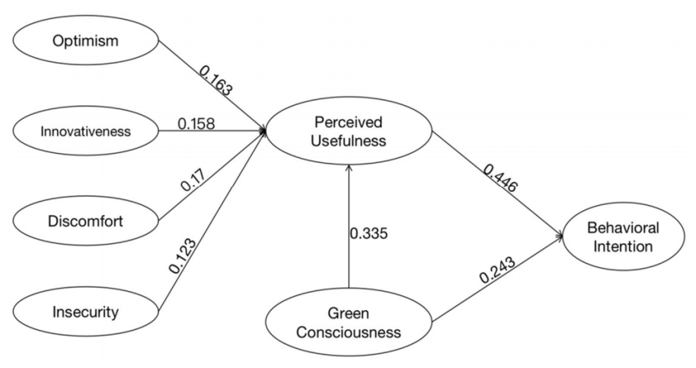

Figure 1. The Title of the Figure

**3 Research method**

**3.1 Measures and validation**

3.1.1 Measurement items

The questionnaire was made available for the respondents to self-administer by means of an online platform. Measurement items in the questionnaire in this paper were standardized on a Likert 7-point scale. Where "1=total disagreement /total non-compliance” and "7 =total agreement / full compliance.

(1)……

①……

A……

a……

**4 Data analysis and results**

The evaluation of the measurement model entailed assessing both its reliability and validity to ensure the accurate measurement of the constructs by their respective indicators. Findings from the analysis indicated that all factor loading values within the sample were at 0.7 or higher. Structural reliability was confirmed through the utilization of Cronbach’s alpha and composite reliability tests, with all outcomes showcasing robust reliability, surpassing the 0.7 threshold (Alyoubi et al., 2018). Furthermore, the average variance extracted (AVE) surpassed the acceptable threshold of 0.5, indicating adequate internal consistency. The detailed results of the validity and reliability assessments are elaborated in Table 1.

Table1. Hypothesis testing

|  |  |  |  |  |  |  |  |
| --- | --- | --- | --- | --- | --- | --- | --- |
| Hypothesis | Constructs | Coefficient | Sample Mean | Standard Deviation | t-value | p-value | Decision |
| H1 | GDTL→SD | 0.244 | 0.244 | 0.045 | 5.424 | 0.000*** | Supported |
| H2 | GDTL→GI | 0.273 | 0.269 | 0.069 | 3.945 | 0.000*** | Supported |
| H3 | GI→SD | 0.443 | 0.442 | 0.047 | 9.356 | 0.000*** | Supported |
| H4 | NP→SD | 0.373 | 0.376 | 0.051 | 7.335 | 0.000*** | Supported |
| H5 | NP→GI | 0.441 | 0.447 | 0.067 | 6.584 | 0.000*** | Supported |

Notes: ***p<0.001, **p<0.01, *p<0.05

**5 Conclusion**

This study analyzes the impact of internal green digital transformation leadership, external normative pressure, and green innovation on sustainable development in enterprises located in Eastern China. By introducing green digital transformation leadership as a prerequisite for corporate sustainable development, this research contributes to the existing literature on corporate leadership. Additionally, the study explores the effects of normative pressure and green innovation on sustainable development. Green innovation serves as a mediating variable, partially influencing the impact of green digital transformation leadership and normative pressure on sustainable development. The results provide theoretical and empirical support for the association between green digital transformation leadership and sustainable development in manufacturing enterprises in Eastern China.

**References**（APA format，providing the DOI of literature）

Ahmad, M., ＆ Wu, Y. (2022). Combined role of green productivity growth, economic globalization, and eco-innovation in achieving ecological sustainability for OECD economies. Journal of Environmental Management, 302, Part A:113980. https://doi.org/10.1016/j.jenvman.2021.113980.

Alyoubi, B., Hoque, M.R., Alharbi, I., Alyoubi, A., ＆ Almazmomi, N. (2018). Impact of knowledge management on employee work performance: evidence from Saudi Arabia. The International Technology Management Review, 7(1), 13-24. https://doi.org/10.2991/itmr.7.1.2.

Boulhaga, M., Bouri, A., Elamer, A. A., ＆ Ibrahim, B. A. (2023). Environmental, social and governance ratings and firm performance: the moderating role of internal control quality. Corp Soc Responsib Environ Manag, 30(1), 134-145. https://doi.org/10.1002/csr.2343.

Freeman, R. E. (1984). Strategic management: a stakeholder theory. J Manage Studies, 39(1), 1-21. https://doi.org/10.2139/ssrn.263511.

Zameer, H., ＆ Yasmeen, H. (2022). Green innovation and environmental awareness driven green purchase intentions. Mark Intell Plan, 40(5), 624-638. https://doi.org/10.1108/MIP-12-2021-0457.

**Author Introduction** (At least including First and Corresponding Authors)

First author, Meimei Han, Female, born in 1980, Ph.D., Professor, Dept. of Global Business, Kyonggi University, Obtained a PhD in Business Administration from Yonsei University in 2011 ，research interest in digital economy, email: meimeihan @ gmail.com.



Corresponding author, Lei Li, Male, born in 1980, Ph.D., Professor, Dept. of Global Business, Kyonggi University, Obtained a PhD in Business Administration from Yonsei University in 2011 ，research interest in digital economy, email: leili @gmail.com.



1. Fund：

   *Author Correspondence: (First author) Meimei Han (meimeihan @gmail.com), (Corresponding author) Lei Li (leili @gmail.com)

   Received xx April 20 xx， Revised xx May 20 xx，Accepted xx June 20 xx